MARCH FOUNDER/CEO REPORT OF MISSION TRIP TO KENYA & LIBERIA

Arrived tired but good flight having lost many hours sleep.  Delayed as they had lost my luggage received the two suitcases after two days.  Florence, my host, coming to the rescue with temporary clothes.

 Cheered up as met by smiling faces of executive of TJG Kenya now 4 am.

Rested, then meet with Rev. Peter Muskoya and ministered to Masai leaders on Jesus came to redeem.  Team helped give out over 200 food packs.  How Bishop Peter and his wife arranged this so quickly is a credit to them as could only send monies day before. Powerful time, the Masai leader stepped forward and repented, after word of knowledge for the sins of his tribe of ungodly covenants and acts made over the land.  Asked and agreed to take this message of repentance to the other Masai leaders.  I prophesied as they did this the rains would come.  Which I believe has happened.

Next day long 8 hour drive down to Homabay for launch at Waondo Polytechnic of Love and Care Africa and Dadrego agriculture project which we are partnering with. Excellent opportunity to get to know the other CEOS. Had the privilege of planting trees with other ministers, quite a feat as holes were so deep.  Our part as TJG is capacity building.  Will meet again with CEOS to find out more. I shared briefly TJG history and a little about us with all those present.  Many were interested and asked many questions.

Whilst in Homabay, hosted by Rose, our relief coordinator, set up a subcommittee answerable to Kenya trustees on agriculture projects, starting with Homabay.  Rose had already donated 5 acres of land, and Mary has now also given us 5 acres for our use free. Since my return this land has now been planted with maize and beans.  Project chaired by Eng John Guda who is overseeing the project, along with Martina, Mirriam, Mary, Rose, and TJG national executive. Expertise given by Peter Caleb.  Committee called Change Your Story.

We flew back from Homabay on such a quick flight.  Following three days were taken with outdoor crusade at Mathare.  Surprised how different it is speaking at a crusade compared to conference.  Many lives changed with over 60-80 salvations. Met my sponsor, Pastor Tony King and his friend Bishop James.  It was good to meet Bishop Kennedy Mutange of Megah Church Christian Fellowship again and ministered at his church on the Sunday morning on offence.  Many people responded.

The journey to Muranga Prison was very eventful and I am sure it was the power of prayer which saved our lives. First time we broke down we made it to a layby only to be greeted by three police officers who demanded Apostle Stephen Momanyi's driving licence and accused him of being drunk and we could have caused an accident. Apostle replied calmly that we had put our hazard lights on as we made our way across the three lanes to check what was wrong.  Finding out later, brake pads had been adjusted incorrectly, causing the brakes to seize.  Pastor Veronicah heard them say in her local dialectic “white lady, money”.  They were surprised when she greeted them in their local dialectic, also discovering they knew some of the same people in her village.  When she told them we were pastors, they let us go.

Second time was more serious now in the outside lane of a fast moving three lane carriageway. We came to a sudden halt, my goodness, did we pray earnestly, somehow, we moved to the inside lane and Apostle Stephen made an adjustment which worked. Thankfully, a few yards ahead was opening to another 3 lane carriageway, which we crawled across to the petrol station. Angels clearing the way, as no traffic to hindered us. As the CEO decided, we were not carrying on in the same car. We all disembarked too taxis. Car now repaired after the Toyota garage, wanting over £1,000 for repairs. We removed it and used Japanese parts. Now back on the road but costly hiring cars and repairing it.

At the prison, over 80 women prisoners were waiting for us. I spoke about taking your labels off.  What you have been labelled with does not need to define you. They enthusiastically tore off the labels they and others had put on them. Three people gave their lives to the lord, and others instantly healed after words of knowledge. Alongside Pastor Tony King’s mother, we distributed sanitary pads, baby pampers, bread and milk to the prisoners.  Thank you, Pastor Tony, for sponsoring this and my flight.  Our prison coordinator Anthony is busy planning to visit other prisons.  The governor of the prison took us to see the beautiful handiwork of the women. I brought a colourful bag which will remind me to pray for them.  If you want to be part of the prison ministry, get in touch with Anthony, THE JOSHUA GENERATION PRISON MINISTRY KENYA. https://chat.whatsapp.com/CQFkBBWGiswJXcwAT31geK.

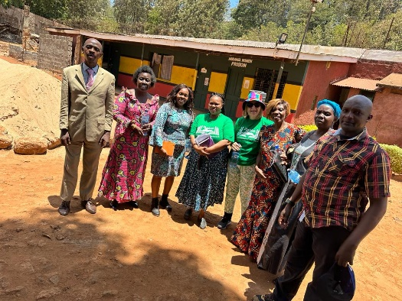

Some of Prison visiting team

Three-day outdoor crusade kept me busy at Mathare, sponsored by Pastor Tony King, thankfully weather was good. Many healed, delivered, and gave their lives to the Lord.

What you have seen in the photos of the feeding programme in Mathare does not do justice to all the hard work and organising that goes on.   We arrived to seeing bodies on the floor asleep. They quickly woke up when they realised the food was about to be served.  TJG team, I was so proud of you as you coped with hundreds of people waiting.  Thankfully, it was peaceful, and one lady asked us to pray for her sick baby and thanked us for the food she could take back to her.  This led to many others holding the microphone and saying thank you.  We ended the day praying for those who had given their lives at the Mathare Crusade. They had already started attending Megah Christian Fellowship.  I had new revelation about what it is like to serve that many people with beans, arms and hands were aching.  The smile on people's faces, we are calling them our rough diamonds, made it all worthwhile.  We must have served well over 300 people, if not 400.

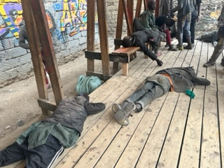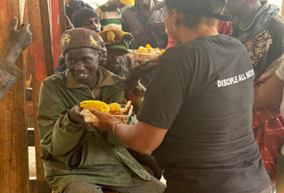 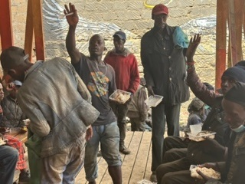 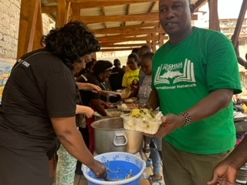

Next day was the launch of the Chooka Vocational College and Fire House of Prayer.  Must admit could not wait for the launch and went the day before.  It had only been running for three days and was a hive of activity.  Over 6o girls have signed up and another 40 are waiting to join.  People were having their hair washed, others were learning how to plait.  Encouraged by girl’s testimonies of how this was changing their lives.  Meeting many of the mums we had originally ministered to over four months before.  The Holy Spirit clearly spoke to me and confirmed by others that he wanted TJG to help them.  Now, less than four months later, seeing the answer in action was very humbling. One mother shared how she was now back with her parents, who were proud of her trying to change her life.  She said it had helped restore her relationship with them.  Another said it was helping her to provide for her children.  The tailoring, dressing making and hand sewing class proudly showed us how they were learning different stitches and how to gather.  Their stitching was neat.  Again, they were telling me they were going to set up their own business.  Agreed, we needed to add another course in finance and running a business.

Nex day launch a wonderful display of branding, girls and women proudly wearing our green t-shirts.  Matched the gate painted in our logo and banner across.  The Bishops from Kigali also joined us, as well as many dignitaries from the government.  Nairobi women leaders, thank you for inviting me to your launch. I am sad my camera had run out of power and other photos got wiped by mistake.

.

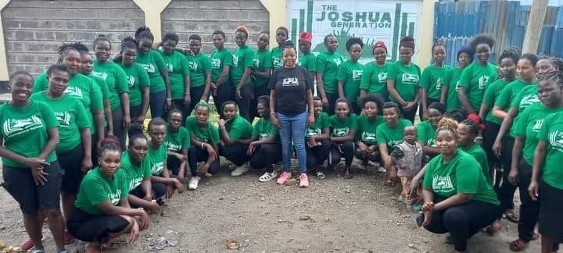

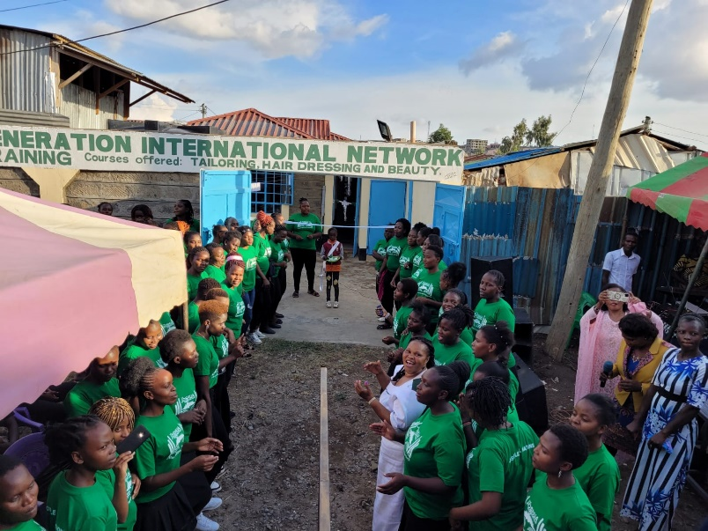

Pastor breakfast in Kigali. After sharing the vision. We were given two classrooms for another vocational centre in Soweto the pastor concerned already runs two schools, primary and secondary, and is keen for us to set up one in Soweto having seen what we are doing in Chooka. Now changed to big classroom on top floor which will give us more space to offer, tailoring, hairdressing and beauty and soap making. He agreed he will pay for trainers; we pay for the equipping. Plus, donation towards cementing of floor. Premises given free of any charge. Once again God is blessing us. Reminds me of when they shared all things in common.

Next three days very busy with Thika crusade. Watched as God did miracles of healing, lumps vanishing as I laid hands on them. Swollen ankles going back to normal size, so many signs and wonders happening before our eyes. Holy Spirit doing what he does best changing lives. Many, many people gave their lives to the Lord. One lady had been married off three times by her father, each relationship abusive, gave her life to the Lord and others witnessed the smile which appeared on her face as she experienced the peace of God. Next day was able to link her with Nancy who will follow her up and counsel her as appropriate. Ministered on the Sunday at Bishop James church again the Holy Spirit moved powerfully many slain in the spirit. Followed by vegetarian lunch at a golf club welcome change and chance to get to know Bishop James more. We arranged to meet the next day for dinner but unfortunately due to the riots they got stopped outside Thika where tear gas was thrown at their car but made it home safely. My last day was spent in a whole day of meetings all of which were fruitful. We now have marketing team who will help with social media presence and literature, documentary we can use as we seek for sponsorship towards Africa Summit in December.

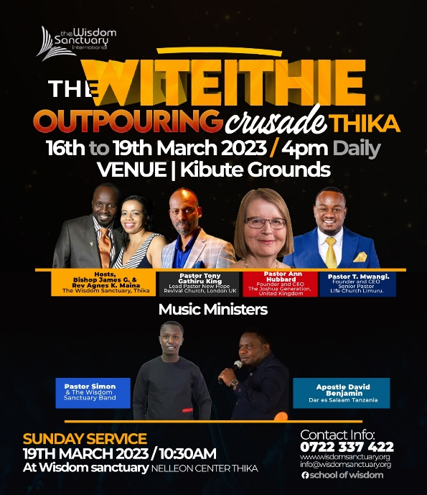 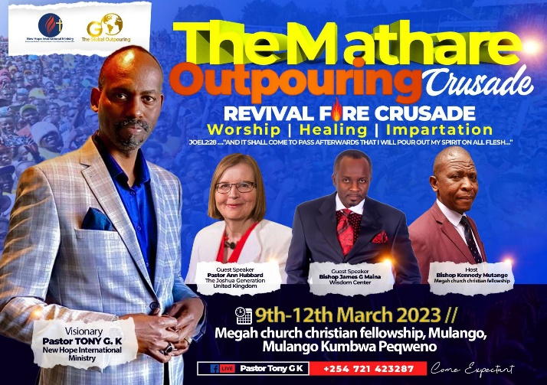

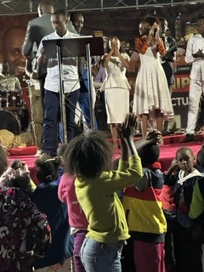 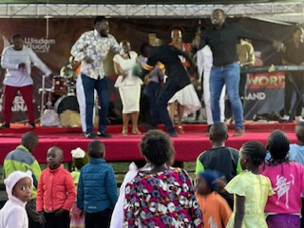

Long flight to Liberia, change over shorter than anticipated but made it. Welcomed by Pastor Dixon and executive, car paid for by Pastor Tony King who was arriving the following day. First night stayed in Pastor Dixon place, woken at 4am to join them for prayers after only a few hours’ sleep, how I stayed awake must have been the grace of God. 8am drove to Bombi county, welcomed with feast, so tired just wanted to sleep. Next day shared with Pastors at Bombi TJG vision and how we had been given premises for vocational colleges. They shared how much they would like one as well. Expounded on the principal of using what you have in your hands, and we come to empower and not give money. In response the headmaster of the school hall we were meeting in, offered us the school premises in the afternoon for a vocational centre. We then asked what skills were in the room, turned out there was a tailor, carpentry and soap making all willing to be volunteer trainers. Once again God added another vocational centre. This centre will be managed by TJG Bombi county executive. Much to my surprise was given a chicken as a gift, thankfully was delivered the next day and enjoyed by all.

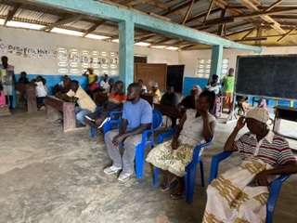

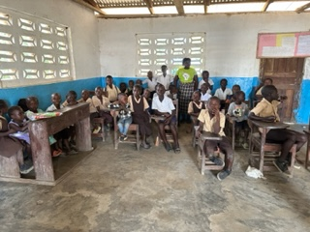

Bombi future vocational centre, school hall given, you can see how large it is.

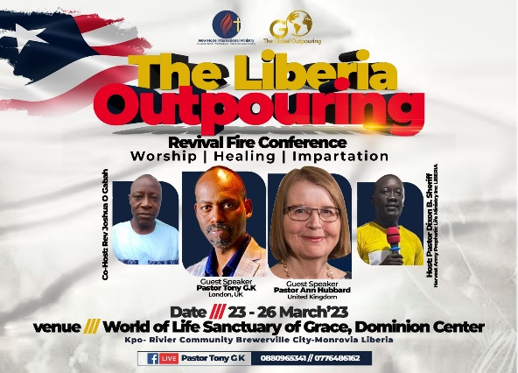

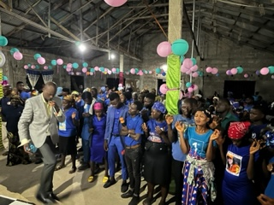

Three day Liberia Crusade, many healed and delivered set on fire for revival after impartation.

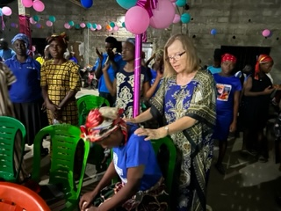

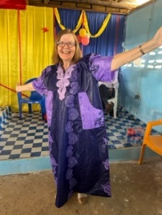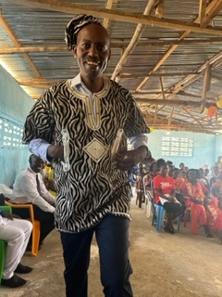 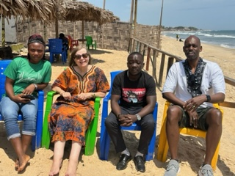

Gifts received by both of us from Pastor Dixon and his church after ministering at his three years celebration. Day of refreshing beside beach, even had a paddle., followed by meal at restaurant. Said goodbye to Pastor Tony King who was flying back to Kenya for another three-day crusade.

We proceeded to Gantz another long drive, cut ribbon of vocational school with Liberia education minister school, again used in the morning as school and afternoon vocational. Surprised by news that they had planted the land given to us on last visit in Bong county. Made the mistake of saying would like to see our other vocational centre. The mistake was by now we had changed cars to something less expensive and after the luxury of other executive car, this one was a bone shaker. No one told me to get to the school would be two hours of unmade up roads, brief respite in middle where road started but not completed. Forgive the moan but worth it to see the gift of the school we have been given. The school was bigger than I thought, fully equipped with desks and chairs and only needs minor repairs of $450 for us to be able to open it as primary school and vocational school. Was awe struck at the goodness of God to us. Even painted in our green. A whole school given to us plus land, free of charge for us to use. This is Gods glory in action with football field and goal posts.

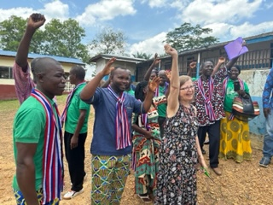

Gantz launch of vocational centre, school we are using in background  
Vocational Department Courses:

1. Baking and catering.

2. Events decorations.

3. Cosmetology

4. Soap making & Tie dye.

\*Professional Department Courses:

1. Agriculture.

2. Nurse aid.

3. Education, teachers training

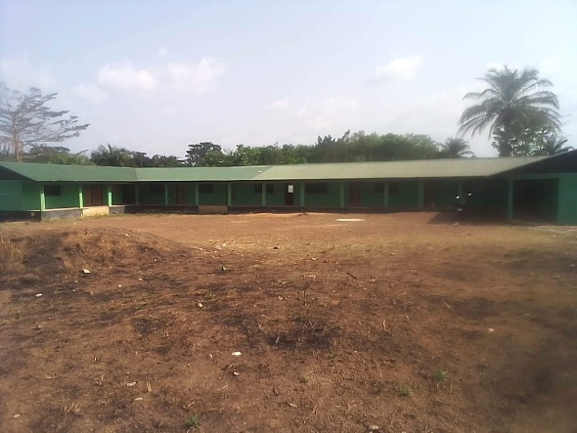

School we have been given in Nimba County Saclepea. Plans for it to be Primary school in morning. Afternoon vocational centre.

In process of making repairs to mosquito screening and leaks.

After driving most the night, brief sleep in car. All too soon I was on the plane back to the UK and welcoming arms of my husband. Greeted when home with bouquet of flowers. Thank you to all who made this a memorable mission, and to all our hosts, sponsors, your help is invaluable. We accomplished much together but as you can see, we can even achieve more working together.

Blessings

Pastor Ann Hubbard

Founder/CEO TJGINT

